**CLOUD COMPUTING LAB1**

DESKTOP VIRTUALIZATION:

To this step we need to download the virtual box and ubuntu desktop:

Then install virtual box. Inside the virtual box in the tools

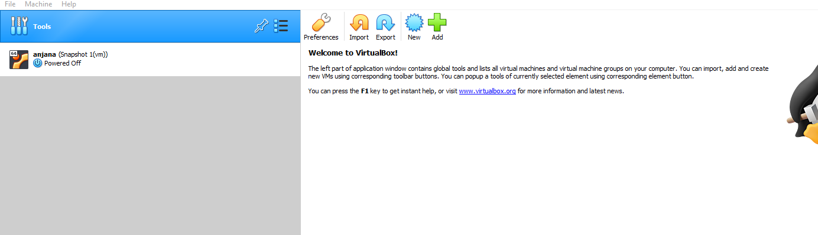

Added the ubuntu-18.04.6-desktop-amd64 into the optical disks from tools.

Open file in file ->virtual manager

Go to optical disks and add

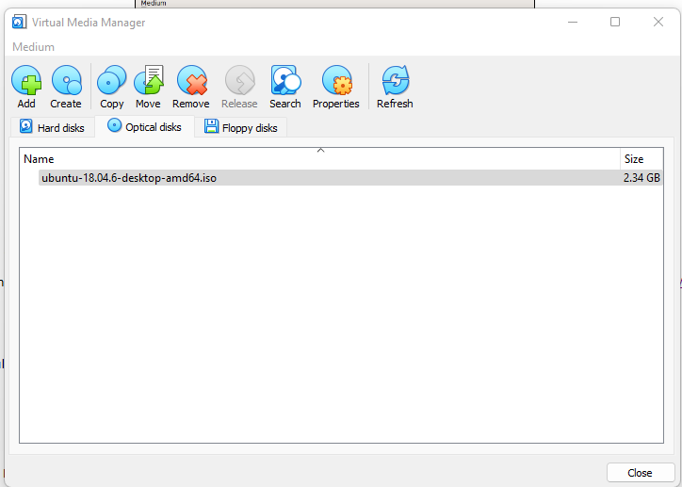

Unmount/eject the disk image from the CD drive.

Changed the network to NAT Network to Bridged Network.

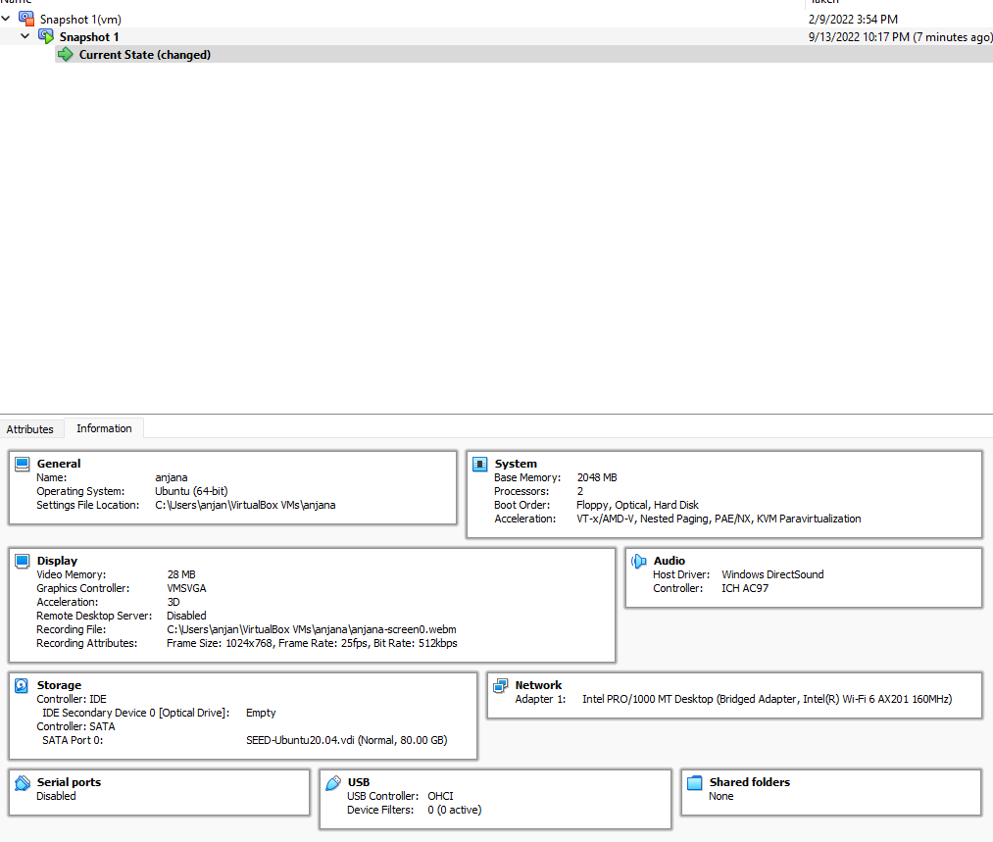

**Ifconfig:**

To find ipaddress we run the command ifconfig.

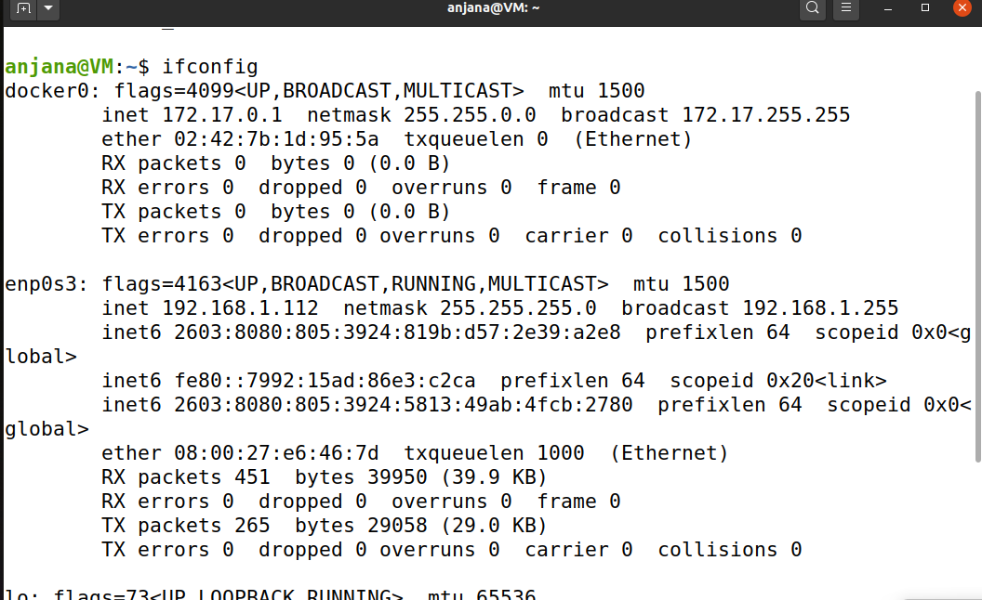

**2.To Install Apache, we need to update**

Sudo -apt update

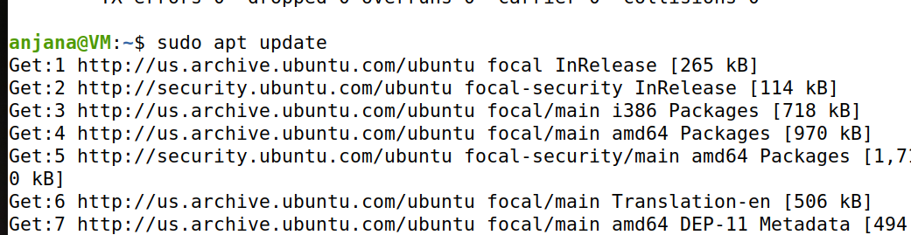

To get apache2 install

Sudo apt install apache2

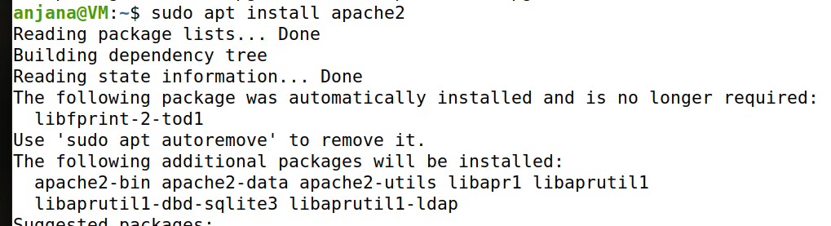

Step 2 — Adjusting the Firewall

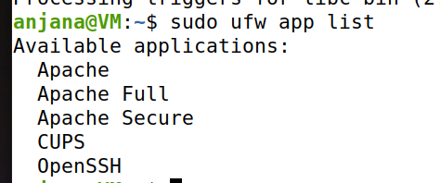

To allow space

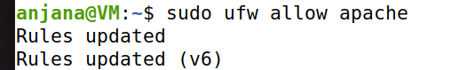

To check your webserver is working fine

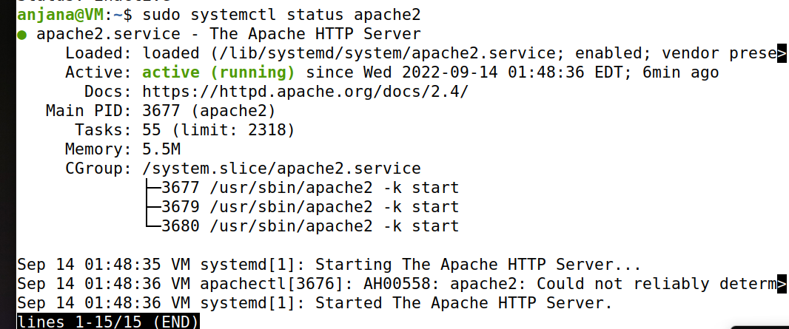

The Apache 2 is working on the given IP address

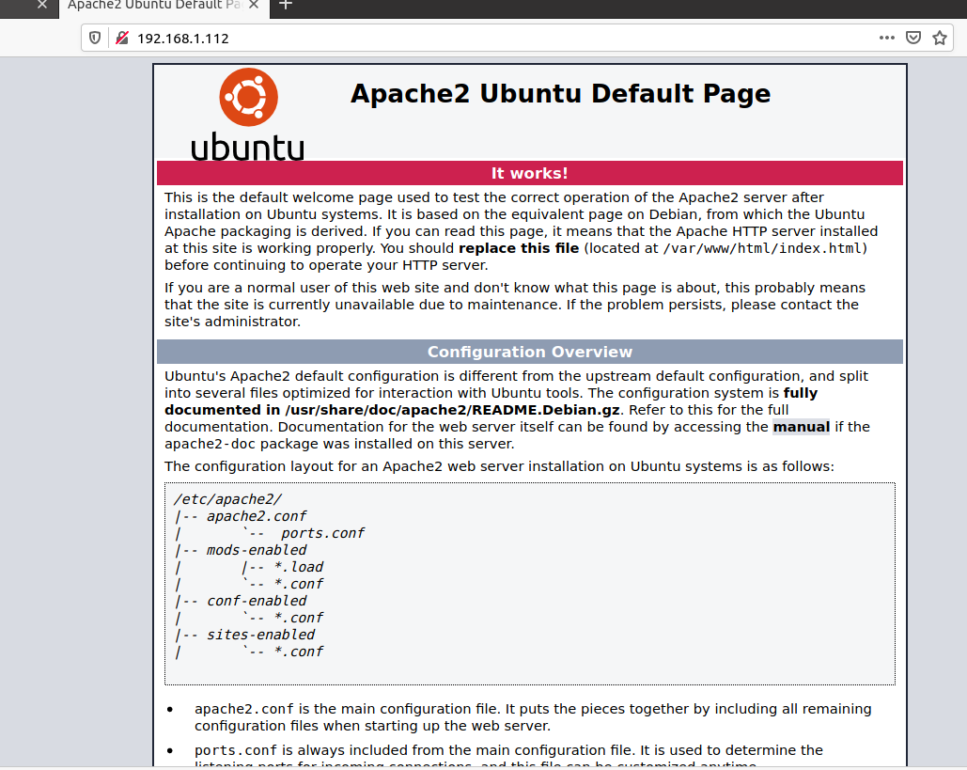

To validate connection this command is need to be runned

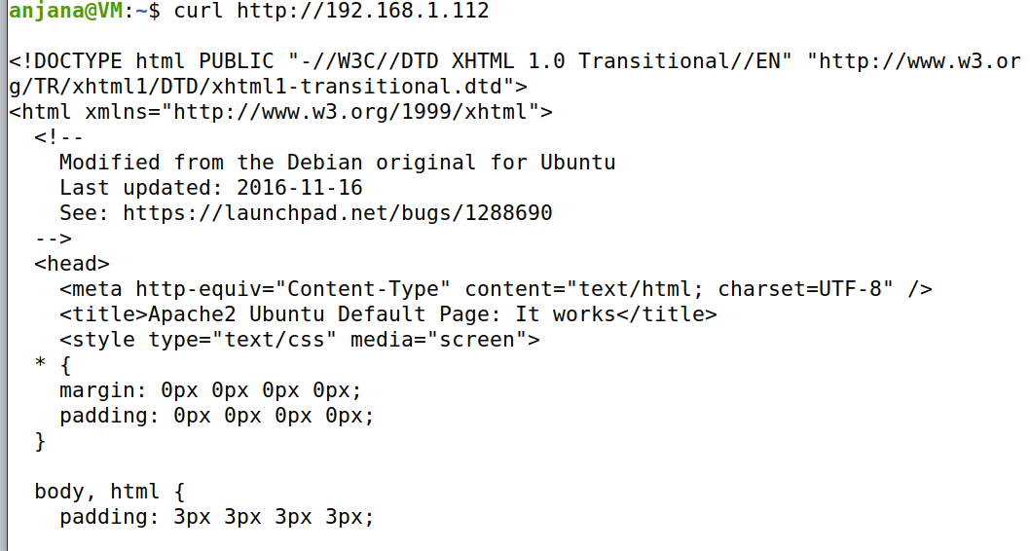

**Part2: Install GCP CLI on VM:**

Installation the cloud CLI:

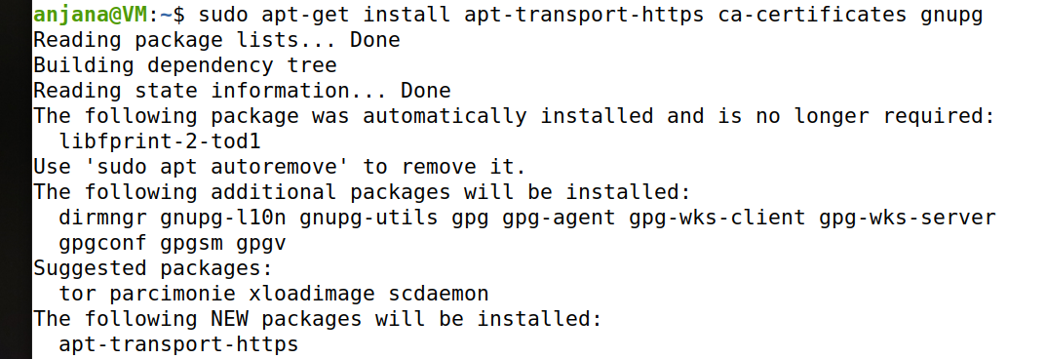

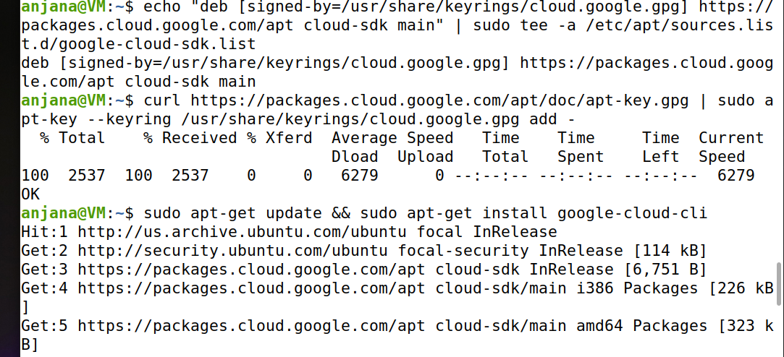

By the Above command is used to Add the gcloud CLI distribution URI as a package source.

The below command is used to Import the Google Cloud public key

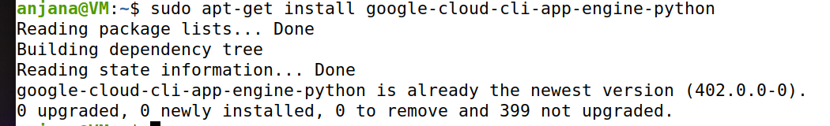

The installed google cloud platform can be Initialized by using the below command

2.

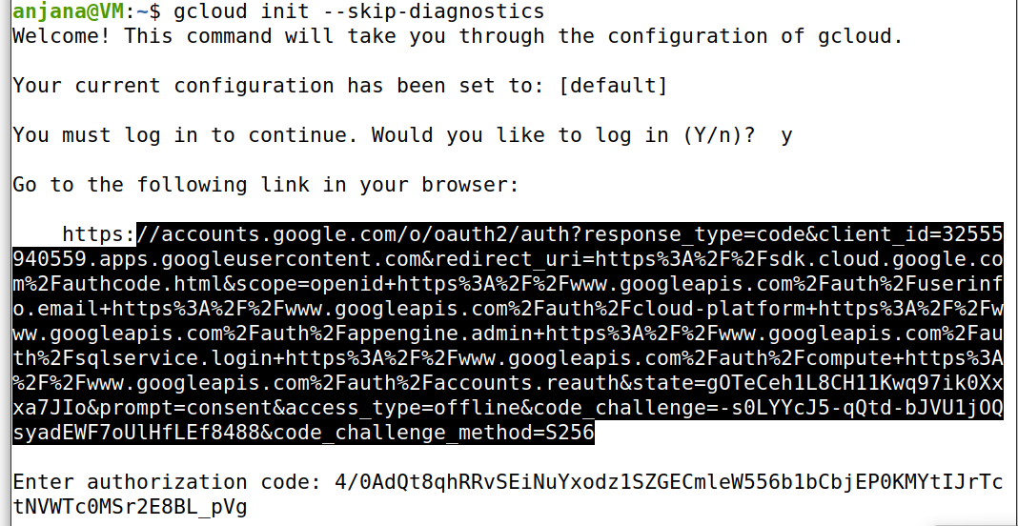

2.. Configure the GCP CLI environment with API details and default region

In this we configured the gcp cli environment details and default region

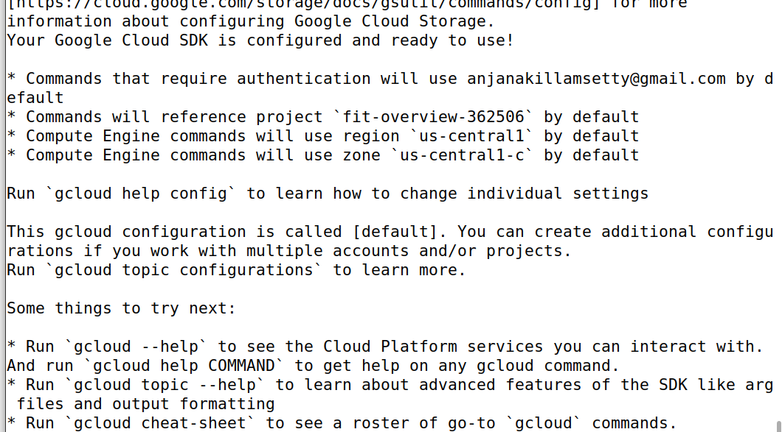

Now it logged in with my GCP account

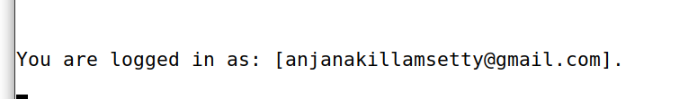

To run the boto script we need to have python.

Checking python version:

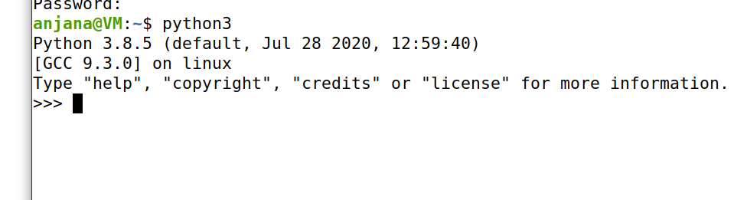

To know the gcloud information:

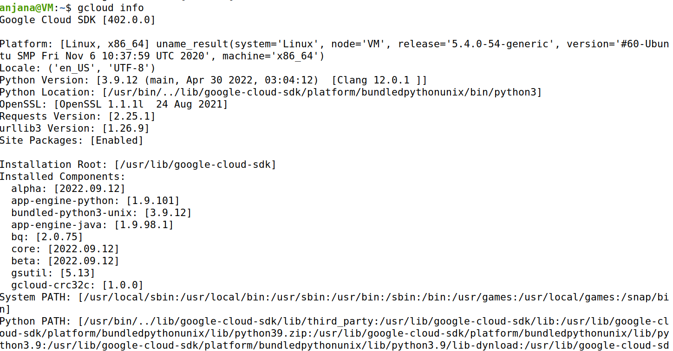

3.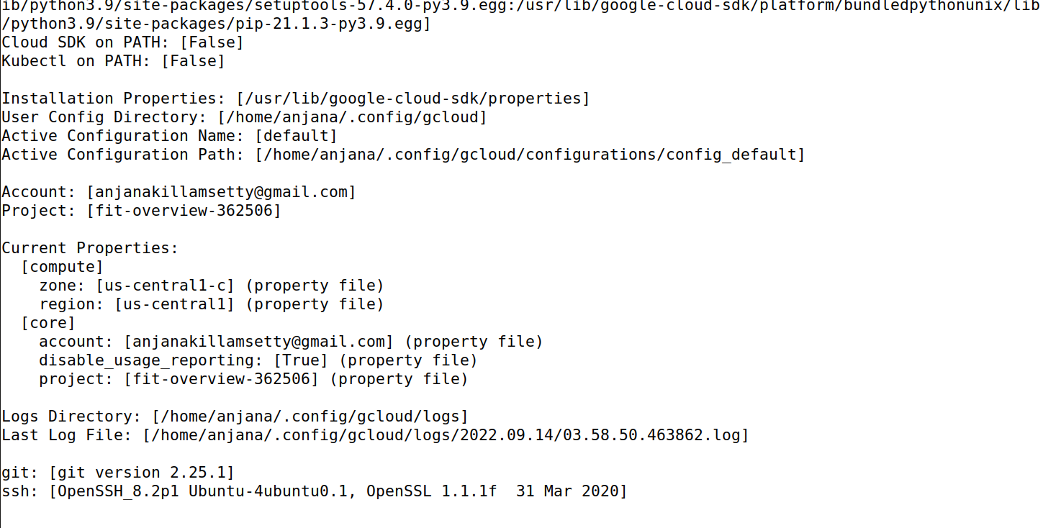

3. Verify GCP CLI is working and write a python boto script to emulate a GCP CLI command

To emulate the GCP CLI command we need to python boto script

Install boto script

Boto_script.py

It is used to get the bucket list from boto script .

4.Test the environment by listing the accounts whose credentials are stored on the local system, the properties and information in your active Cloud SDK configuration, and the component list.

This is the below access key id is same ID in google service account.

Below are credentials used to config the service account

